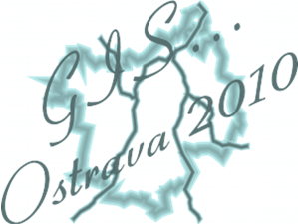
Author's Statement Form
Symposium GIS Ostrava 2010

Symposium proceedings: GIS Ostrava 2010

Name of the paper:................................................................................................................
.................................................................................................................
..................................................................................................................
Author’s name:.................................................................................................…...................
Author’s address: ...................................................................................................................
..................................................................................................................
Please complete in block letters.

The author states hereunder that
the right to use the listed paper was given free of charge to the VSB - Technical University of Ostrava. Granting authorization to exercise the right to use the listed paper included a non-exclusive right to reproduce and distribute the listed paper, including re-editions, translations, photocopies, microforms, and electronic media (offline or online) or any other reproductions of similar type. It was agreed that the first written publication of the listed paper would be made in the above-mentioned proceedings. VSB - TU Ostrava (Institute of Geoinformatics) will publish the listed paper at its own expense.
The author will publish the listed paper at his/her personal web page provided that he/she will make reference to the web page of the proceedings and that in this electronic version he/she will clearly show by marking “© VSB-TU Ostrava (Institute of Geoinformatics)“ that VSB-TU Ostrava (Institute of Geoinformatics) owns the proprietary copyrights. The author acknowledges that it will be appropriate to make the full text of the paper available on his/her personal web page 12 months after the above-mentioned proceedings are published; this restriction shall not apply to publication of an abstract.
The author states that the listed paper is original, except for quotations from other authorial work, that the paper does not contain any offensive statements and does not infringe any copyrights, trademark rights, patents or other rights of third parties. The author made a license agreement, signed this statement on copyrights and took responsibility for publishing of the listed paper on behalf of all possible co-authors.

Date: ....................................... Author’s signature: ............................................

